Postal Life Insurance

Department of Post

Software Requirements Specification (SRS)/ Functional Requirements Specification (FRS)
  - UMANG Mobile App

INTERNAL APPROVAL FORM

Project Name: UMANG Mobile App
Version: 1.0
Submitted on:
 | Name | Date
Approved By:
Reviewed By:
Prepared By:

VERSION CONTROL LOG
Version | Date | Prepared By | Remarks
1

Table of Contents

1. Executive Summary 4
2. Project Scope 4
3. Business Requirements 4
4. Functional Requirements Specification 5
4.1 Policy Dashboard page 5
4.2 Premium Payment Page 6
4.3 Service Request page 6
4.4 Policy Purchase page 6
4.5 Language Settings 7
4.6 DigiLocker Upload Page 7
5. Attachments 7

1. Executive Summary
This document outlines the requirement for integrating the UMANG mobile application with the Insurance Management System (IMS) of India Post PLI/RPLI. The integration aims to provide seamless digital access to insurance services for customers via UMANG.

2. Project Scope
This scope will include the integration of Insurance Management System with UMANG Application.

3. Business Requirements

ID | Requirements
FS_UM_001 | Enable PLI/RPLI customers to view policy details via UMANG.
FS_UM_002 | Allow digital premium payments through UMANG using UPI, cards, net banking.
FS_UM_003 | Provide service request and grievance submission and tracking.
FS_UM_004 | Facilitate new policy purchase and product comparison.
FS_UM_005 | Support multilingual interface via Bhashini for rural accessibility.
FS_UM_006 | Integrate DigiLocker for document submission during policy purchase or claim.
FS_UM_007 | Enable e-Bond generation for new policies.
FS_UM_008 | Provide reminders for premium due dates and default alerts.
FS_UM_009 | Ensure secure, real-time data exchange between UMANG and IMS.
FS_UM_010 | Allow download of policy documents and certificates.

4. Functional Requirements Specification
Use Case Diagram for UMANG Integration with IMS: 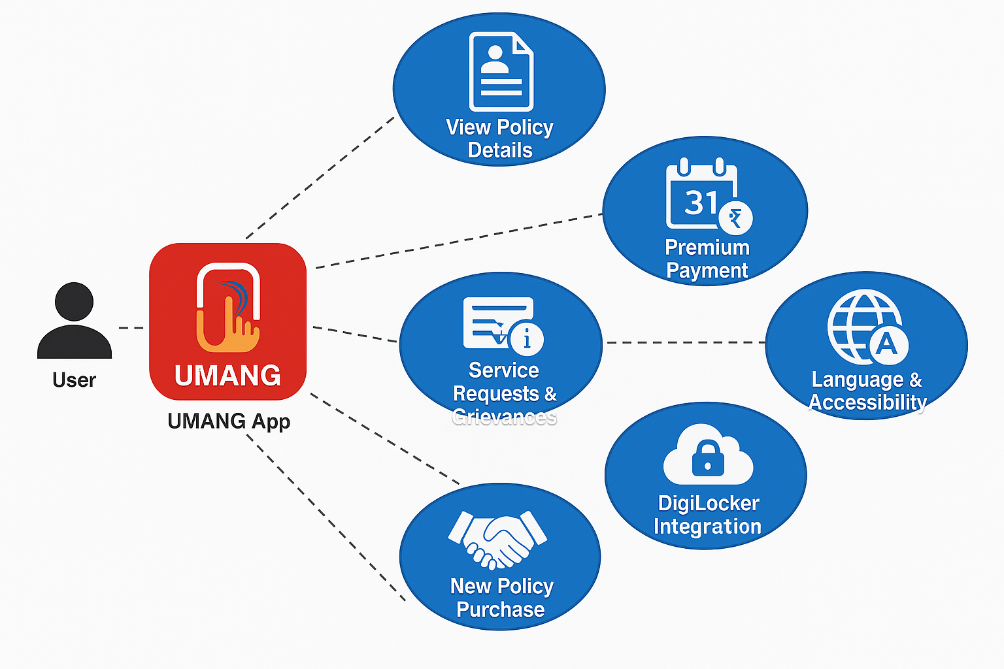

4.1 Policy Dashboard page
- Purpose: Policy Dashboard in UMANG App will display policy details from IMS via secure API and it also allow document downloads in PDF. Customers can view active/inactive policies with full details (sum assured, premium, term, bonus) including accrued bonus, download policy document, certificates including income tax certificates, and track proposals, policies, and claims.

- Fields:
  - Policy Number: Text: Unique identifier of the policy
  - Policy Status: Dropdown: Active / Inactive
  - Sum Assured: Numeric: Total coverage amount
  - Premium Amount: Numeric: Monthly/Quarterly/Annual premium
  - Term: Numeric: Policy duration in years
  - Accrued Bonus: Numeric: Bonus accumulated till date
  - Download Documents: Button: Downloads policy certificate and IT certificate

4.2 Premium Payment Page
- Purpose: Premium Payment page will Integrate with Bharat BillPay or payment gateway for performing premium payment for PLI/RPLI Policies. It should Trigger payment confirmation to IMS and Update payment status in IMS. The insured may also set up an auto-debit facility for future premium payments. Additionally, the UMANG mobile app can send timely reminders for upcoming premium due dates and alerts for any applicable default fees. Pay premiums via UPI, debit/credit cards, or net banking etc.

- Fields:
  - Policy Number: Text: Auto-filled from dashboard
  - Due Amount: Numeric: Premium due
  - Payment Mode: Dropdown: UPI / Debit Card / Credit Card / Net Banking
  - Auto-debit Setup: Checkbox: Enable auto-debit for future payments
  - Reminder Notification: Toggle: Enable SMS/Push alerts for due dates

4.3 Service Request page
- Purpose: Service Request Page will allow the user to Submit request to Insurance Management System and Generate ticket ID and allow status tracking. Users can submit service requests and grievances through UMANG and track their status via IT 2.0 and CRM integration with UMANG.

- Fields:
  - Request Type: Dropdown: Address Change / Nominee Update / etc.
  - Description: Text Area: Details of the request
  - Upload Supporting Docs: File Upload: Optional document upload
  - Track Status: Button: View current status of request

4.4 Policy Purchase page
- Purpose: Policy Purchase page should allow a user to issue the policy digitally. It should Suggest plans based on age/income, allow policy procurement, Integrate with DigiLocker for document verification and Generate e-Bond and send to Insurance Management System.

- Fields:
  - Customer Name: Text: Full name of applicant
  - Age: Numeric: Age of applicant
  - Income: Numeric: Annual income of applicant
  - Preferred Plan: Dropdown: Suggested based on input
  - Compare Plans: Button: Show comparison of PLI/RPLI plans
  - Upload KYC Docs: File Upload: Via DigiLocker
  - Generate e-Bond: Button: Create e-Bond document for policy

4.5 Language Settings
- Purpose: The Content should get displayed in other languages also if selected by the user in the UMANG Application.
- Fields:
  - Preferred Language: Dropdown: Hindi / Tamil / Bengali / etc.
  - Accessibility Mode: Toggle: Enable simplified UI for rural users

4.6 DigiLocker Upload Page
- Purpose: User should be able to Authenticate via DigiLocker, Fetch verified documents and Submit to Insurance Management System for policy or claim processing.

- Fields:
  - Document Type: Dropdown: Aadhaar / PAN / Income Proof / etc.
  - Upload via DigiLocker: Button: Launch DigiLocker picker for document upload
  - Status: Text: Uploaded / Pending

5. Attachments
The following documents can be referred.

